**CSE103L Circuits & Systems-I Lab**

**Circuits And System 1**

**LAB REPORT # 1**



**Submitted to:**

**Engr. Faiz Ullah**

**Submitted by:**

**TAYYABA**

**Registration No:**

**19PWCSE1854**

**Semester: 2nd**

**Class Section: C**

“On my honor, as student of University of Engineering and Technology, I have neither given nor received unauthorized assistance on this academic work.”

Student Signature: ______________

Thursday, February 27th, 2020

**Department of Computer Systems Engineering**

**University of Engineering and Technology, Peshawar**

ASSESSMENT RUBRICS LAB # 01

Introduction to Basic Electrical Equipments

|  |  |  |  |  |
| --- | --- | --- | --- | --- |
| **LAB REPORT ASSESSMENT** | | | | |
| **Criteria** | **Excellent** | **Average** | **Nil** | **Marks Obtained** |
| 1. **Objectives of Lab** | All objectives of lab are properly covered  [Marks 1] | Objectives of lab are partially covered  [Marks 0.5] | Objectives of lab are not shown  [Marks 0] |  |
| 1. **Resistance, Voltage & Current** | Correct resistance, current and voltage statements and mathematical expressions are written. Circuit diagram shown is correct and properly labeled  [Marks 2] | Correct resistance, current and voltage statements or mathematical expression or circuit diagram is missing or circuit diagram is not properly labeled  [Marks 1] | Resistance, current and voltage statements, mathematical expression or circuit diagram are incorrect or missing.  [Marks 0] |  |
| 1. **Digital Multimeter** | Properly defined DMM and explained functionality in terms of voltage, current and resistance. Explain all steps required to calculate (voltage, current and resistance) measurement. Properly labeled DMM diagram is shown.  [Marks 2] | DMM and its functionality in terms of voltage, current and resistance are not properly explained. Steps required to calculate (voltage, current and resistance) measurement are partially shown. DMM diagram is shown but not labeled.  [Marks 1] | DMM and its functionality in terms of voltage, current and resistance are not explained. Steps required to calculate (voltage, current and resistance) measurement are not shown. DMM diagram is not shown  [Marks 0] |  |
| 1. **Power Supply** | Power supply is properly defined. Functionality and steps to provide source voltage to circuit are shown. Diagram is shown with all labels and available voltage values.  [Marks 1] | Power supply is not well defined. Functionality and steps to provide source voltage to circuit are not properly shown. Diagram is shown with no labels.  [Marks 0.5] | No steps for functionality of power supply are shown  [Marks 0] |  |
| 1. **Bread Board** | Breadboard is properly defined. Functionality and steps to design series parallel circuit are shown.  Open and short circuits are also defined. Diagrams are shown with all labels. [Marks 2] | Breadboard is partially defined. Functionality and steps to design series parallel circuit are not shown.  Information about open and short circuits are unsatisfactory.  Diagrams are shown with no labels. [Marks 1] | No steps for breadboard functionality are shown.  [Marks 0] |  |
| 1. **Observations & Calculations** | All experimental results are completely shown in form of table for varying voltages and resistances.  [Marks 2] | Experimental results are partially shown and some of the observations are missing  [Marks 1] | No experimental results are shown  [Marks 0] |  |
| Total Marks Obtained:__________  Instructor Signature: ______________________ | | | | |
|  | | | | |

**Introduction to Basic Electronic Components**

**Lab Objectives:-**

1. We will learn about resistance, current and voltage, their mathematical expression and their mutual relationship.
2. We will learn about Digital Multi-meter, use of Digital Multi-meter as ohm-meter, volt-meter and ampere-meter. We will also learn its circuit diagram.
3. We will learn about power supply, its functions and steps to provide source voltage to circuit.
4. We will learn about Bread board, its functions, steps to create parallel circuit and series circuit and learn about open and short circuit.

**Resistance:-**

Resistance refers to the property of materials that allow the flow of electric current. Resistance certainly opposes the flow of current. The unit of resistance is ohms which are represented by the Greek uppercase letter omega Ω.

Symbols for resistance are:-

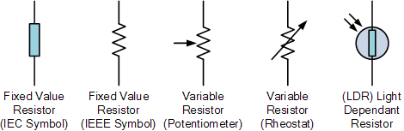

Mathematical expression:-

In terms of voltage and current: **R = V/I (Ohm’s law)**

In terms of resistivity: **R = ƥ * A/L**

**Voltage:-**

Voltage is defined as potential difference across two points. Its SI unit is **volts** and V is its symbol. Voltage can be thought of as the force that pushes electrons through a conductor and the greater the voltage the greater is its ability to “push” the electrons through a given circuit. There are two types of voltage source: **DC Voltage source** and **AC Voltage source.**

Symbols for voltage are:-

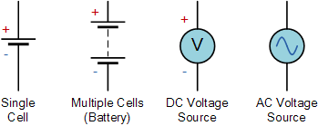

Mathematical expression:

In terms of current and resistance: **V = I*R (Ohm’s law)**

In terms of power: **V = P/I**

**Current:-**

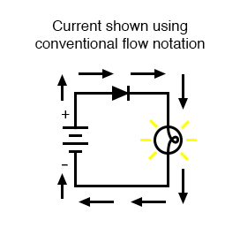 The flow of charges of electron in a material called Current. The SI unit of current is **Ampere** and its symbol is **I**. there are two types of current flows: Conventional Current Flow and Non-Conventional Current flow.

**Conventional Current Flow** is the current flowing from positive terminal to negative terminal.

Conventional Current Flow

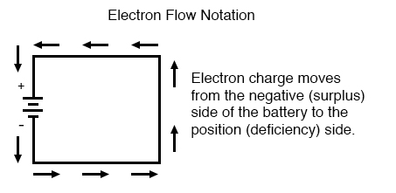**Non-Conventional Current Flow** is the current flowing from negative terminal to positive terminal.

**Mathematical Expression:**

Non-Conventional Current Flow

In terms of voltage and resistance: **I = V/R (Ohm’s Law)**

In terms of power: **I = P/V**

**Digital Multimeter:-**

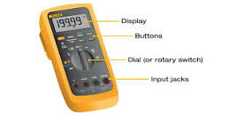 A multi-meter, also known as a VOM, is an electronic measuring instrument that combines several measurement functions in one unit. A typical multi-meter can measure voltage, current, and resistance.

**Functions:**

Using a typical multi-meter, we can measure:

* Voltage in alternating current (AC) and direct current (DC) circuits
* Current in alternating current (AC) and direct current (DC) circuits
* 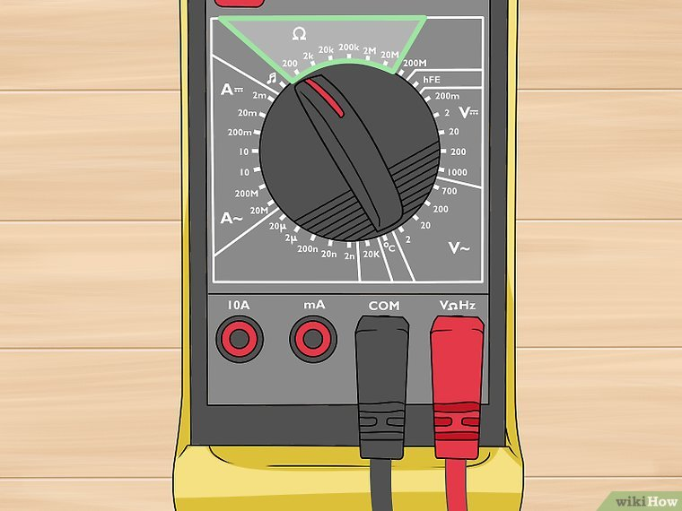Resistance of the entire circuit or across individual circuit components

**How to use Digital Multi-meter:**

Digital multi-meter is easy to use. You just need to know what you are trying to measure.

Suppose we are finding resistance of a resistor place on table. Follow the steps following:

1. Take two wires from input jack of multi-meter. One should be connected to positive input jack and one should be connected to negative input jack.
2. Attach both wires with both ends of the resistor.
3. 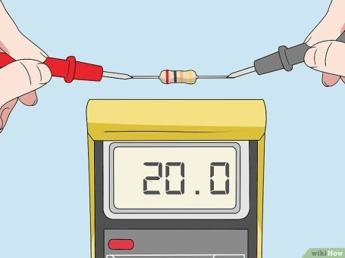Rotate the dial to ohm meter and set the dial to a number above the resistance that’s expected.
4. Place the probes on the resistor to test the amount of resistance.

**Circuit diagram:**

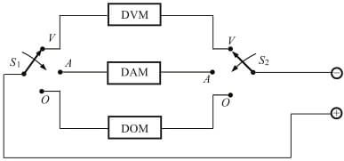

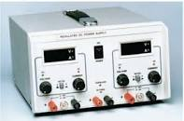**Power Supply:-**

A power supply is a component that supplies power to at least one electric load. Typically, it converts one type of electrical power to another, but it may also convert a different form of energy – such as solar, mechanical, or chemical - into electrical energy.

There are two common types of power supply: **A.C** Power Supply and **D.C** Power Supply.

**Functions:**

The main functions of a power supply include the following:

1. Convert AC to DC.
2. Provide DC voltage to the motherboard, adapters, and peripheral devices.
3. Provide cooling and facilitate air flow through the case.

**How to use:**

Power Supply is easy to use. We can select the voltage to transfer to circuit. Connect two wires from input jack of power supply and connect the ends with points of circuit where positive and negative terminal are placed.

**Circuit Diagram:**

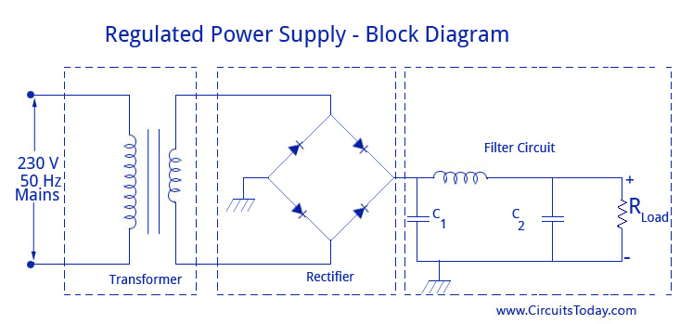

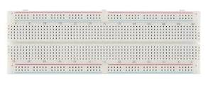**Bread Board:-**

A bread board is a solder less device that is used to make a temporary circuit. It can used to design the circuit, check the circuit that it is working properly or not. The bread board is divided into two parts: Upper portion and lower portion.

In upper portion rows are interconnected. Meanwhile in lower portion columns are interconnected with each other. As shown in figure below:

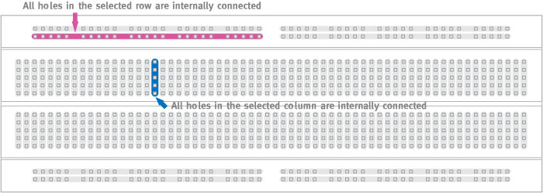

We use a jumper wire to connect upper portion with the lower portion. As shown in figure:

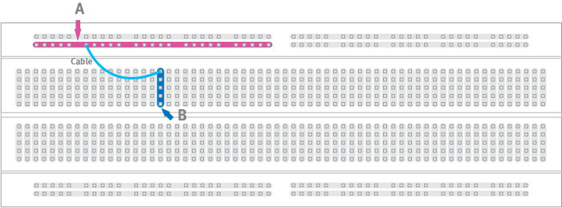

**Parallel circuit:** The parallel circuit in bread board can be established. Suppose we have two resistors and we have to connect it in bread board. If we connect both ends of resistors with both common electric contact points. Then it is said to be in parallel. 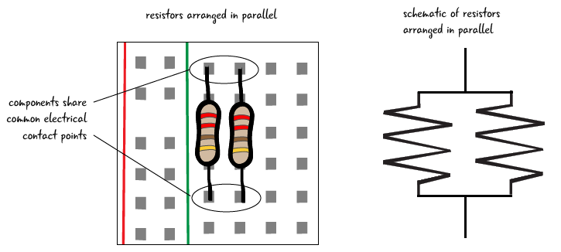

**Series circuit:** The series circuit can be established in bread board. Suppose we have two resistors and we have to connect it in series. If we connect place one resistor and connect first end of 2nd resistor with first end of 1st resistor and move further on. Then connection is said to be in series.

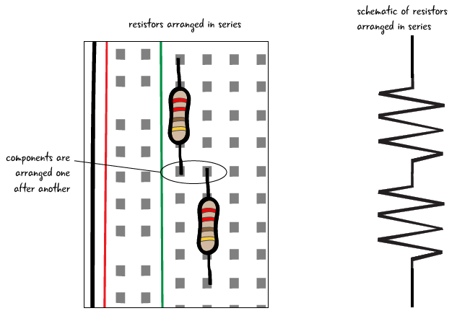

**Open Circuit:-**

An open circuit is a circuit where no current flows. Any circuit which does not have a return path is an open circuit. For example, if you connect wire to the two ends of a battery with a bulb in between, it glows as current flows in the wire because it has a return path or closed path. But, if you remove half part of the wire, then no current flows. Hence this becomes an open circuit.

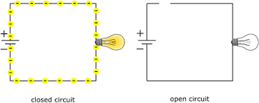

**Short circuit:-**

A short circuit is a circuit where the resistance is very low i.e. extremely high current flows. For example, if you connect the two ends of a battery directly by using a wire without any other components (like resistors) in between then it can be called a short circuit.

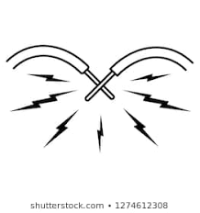

**Observation & Calculation:-**

Error = [(Actual voltage – Measured Voltage)/Actual Voltage]*100 = +- ________ %

|  |  |  |  |  |  |
| --- | --- | --- | --- | --- | --- |
| Serial.No | Actual Voltage | Measured Voltage | Resistance, R | Current, I | % Error |
|  | 5 | 5.21 | 9800 | 5.3* 10-4 |  |
|  | 5 | 5.22 | 978 | 5.3* 10-3 |  |
|  | 5 | 5.22 | 977 | 5.3* 10--3 |  |
|  | 5 | 5.22 | 9.9 | 0.5.3 |  |
|  | 15 | 5.22 | 9800 | 5.3* 10-3 |  |
|  | 15 | 5.22 | 978 | 0.015 | $$±1.467$$ |
|  | 15 | 5.22 | 977 | 0.015 | $$±1.467$$ |

THE END